Saral — Final Product & Brand Documentation

1. What is Saral
Saral is a web app for paying for everyday services, with an AI agent that does the legwork and a safety check that runs before any money moves. Saral means simple, and that is the whole promise: say what you need, see exactly what it will cost, approve it once.
Three surfaces ship from one repository:
Surface | What it is | Platform
Web app | The main product. Mobile-first and responsive, runs in any modern browser on phone or desktop, installable to the home screen. | Website / web app
Public site | Landing page, how it works, security, privacy policy, developers page. Same codebase and domain as the web app. | Website
Browser extension | Chrome companion, paired to your Saral account. Shows your vouchers, subscriptions and autopay on the sites where they apply. | Chrome extension (Manifest V3)
Saral is not a native iOS or Android app, not a bank, and not a wallet that holds your money. Every payment is made by the user, with their own PayPal account, on PayPal's own screens.

2. Project description
Saral turns the everyday things people pay for into one calm, checked experience, and then follows them around the web to make sure nothing they have earned or signed up for slips past.
What we are building
- Mini-apps inside one account. Cinema tickets, power-bank rental, mobile recharge and utility bills share one engine, one account and one payment flow. Restaurants are not a delivery product here; small cafes and restaurants appear as voucher partners, so a payment can earn you a discount at a place you actually go.
- An AI agent that plans but never pays. You type or say what you need. The agent finds options, applies vouchers, keeps to your budget and prepares an exact proposal.
- Voice to start a payment. Speak the request, check the transcript, and the same proposal and approval steps follow. Voice never approves anything by itself.
- The Trust Gate. Between the proposal and the money sits a check on price, risk and integrity. PayPal holds the funds (an authorization) while the check runs. Only then does the payment complete, or the hold is released.
- A browser extension that remembers for you. When you open a site where you hold a Saral voucher, the extension shows it, with its terms and expiry. When you open a service you pay for, it shows that the subscription is active, when it renewed, when it renews next and what you will be charged.
How Saral knows what to show. It only shows what it can stand behind: things you paid for or earned through Saral, plus subscriptions you choose to save from the extension with one click. It does not scan your bank, your cards or your browsing history.
What makes it different
- The agent's spending power is a PayPal hold the user approves, not a stored card or a blank cheque.
- Rewards from one payment show up exactly where they can be used, through the extension.
- Every mini-app follows one published manifest, so a new service is data, not a new codebase.
- Every hold, check, capture and release is explained in plain words in an auditable ledger.

3. Brand story and ideation
The Friday evening problem
It is Friday. You want to catch a film, so you open one app for tickets. Your phone is about to run out of data, so you open another. There is an electricity bill due tomorrow and a third place to pay it. You rented a power bank last week and still have no idea whether your deposit came back. Somewhere in your inbox is a coupon for your favourite cafe. It expired on Tuesday. You found out on Wednesday.
Then the statement arrives and there is a subscription on it you forgot you had. It renewed quietly, as they do.
None of this is hard. That is the frustrating part. It is just a lot of small things, in a lot of places, each asking you to trust it a little.
Then AI showed up, and it made us nervous
Software that can do the errands for you is a good idea. Software that can spend your money is a different sentence. Most of us read that second one and flinch. We should. A tool that moves money has to earn the right, and it has to show its work before it does.
What we kept asking
Could an assistant take over the running around while the person stays in charge of every rupee, dollar or euro that leaves? We kept landing on the same answer. The agent may search, compare and prepare. It may not pay. PayPal can hold the amount without taking it. A check can run while the money waits. And a human decides, once, looking at the exact merchant, the exact items and the exact total.
We called it Hold, Verify, Pay. Hold, Verify, Pay is the whole product in three words.
Where the idea came from
We were drawn to the mini-app model that wallets like PayPay have shown: order food, buy tickets and rent a power bank without ever leaving the wallet. It makes small services feel close. We wanted that closeness on PayPal, with an assistant that does the legwork and a safety step people can actually see. Then we added the piece most apps skip: after you pay, what you earned should find you again. A voucher should appear on the site where it works. A subscription should tell you it is active, and when it will charge you next.
Why Saral
Saral means simple. We did not pick it because it sounds friendly. We picked it because it is the test every screen has to pass. If a step makes someone think harder than the problem deserved, it does not ship.
What we want people to feel
Relief first. Then something quieter and more lasting: the feeling that the software is on their side and has nothing to hide.
Team note: add one true moment from your own lives here, such as a coupon you missed or a bill you forgot. A real sentence will land harder than any line we could write for you.

4. User pain points, our response, and what the demo must prove
Every pain point below needs one visible proof in the demo video. If we cannot show it working, we do not claim it.
User pain point | Saral's response | What the demo must prove
Services are scattered across many apps | One account with four mini-apps on one shared engine | One login completes a flow in each mini-app
Small errands take many steps | The agent turns one sentence into a structured proposal | A spoken or typed request becomes a plan built from real catalogue data
Fear of software spending money | The agent proposes, the user approves the exact amount, PayPal holds the funds first | The approved amount equals the authorized amount; a tampered amount is blocked
Payment states are confusing (held, charged, released) | Plain status words and a timeline per transaction | Opening a ledger row shows every step in order, in plain language
Deposits never seem to come back | Deposit held, final fee captured, remainder released | A power-bank return shows the fee and the released amount
Vouchers expire unseen | The extension shows the voucher on the partner's own site | A voucher card with expiry appears on the matching site
Subscriptions renew silently | Subscription list plus an extension card on the service's site | A card shows active status, last renewal, next renewal and amount
Voice requests can be faked | Voice only starts a request; liveness phrase; approval is always separate | A replayed or altered voice request is stopped before payment

5. Brand narrative for the pitch
Brand line: Digital life, made simpler. Mechanism line: Hold. Verify. Pay.
The spoken version (about 30 seconds)
Think about the last time you paid for something small. A ticket. A recharge. A bill. It took an app, a login, a card and a little hope.
Now picture telling an assistant what you need and getting back one clear proposal: who gets paid, for what, and exactly how much. PayPal holds the amount. Saral checks it. You approve it. Not a second before.
That is Saral. The agent does the legwork. You keep the final say. And once you have paid, what you earned finds its way back to you: the voucher on the cafe's own site, the renewal date on the service you subscribe to.
Digital life, made simpler. Without making trust an afterthought.
Shape of the pitch
- The problem, in one everyday scene (10 seconds).
- The turn: an agent that cannot pay on its own (10 seconds).
- The proof: the live demo, start to finish.
- The reason it matters: AI agents will handle money soon, and the user's approval has to be built in, not bolted on.

6. Product principles, scope and the copy rule
Principles
Principle | Rule we build to
User control | No payment happens without the user's explicit approval of the exact proposal.
Least privilege | The agent can search, quote and propose. It cannot approve, capture or read anything secret.
Server authority | Prices, merchants, stock and totals come from the server. Text written by the AI is never trusted for money.
Explainability | Every hold, warning or block has a one-sentence reason in plain words.
Privacy by default | Optional permissions start off. We collect only what a feature needs.
Fail safely | If a safety check cannot run, the payment waits. It never skips the check.
Honest claims | We say what is real and what is not. No claim of live integrations we do not have.
Composable services | Every mini-app follows one manifest and one quote contract.
The copy rule for every screen
The interface is built for real people, so it carries only words that help them do the next thing. That means:
- No developer notes, placeholder text, lorem ipsum, build explanations or internal terms.
- No marketing filler or self-praise inside the app. Pages describe what a thing does, not how great it is.
- No emojis. One icon set only.
- No "demo", "test" or "synthetic" wording anywhere in the live product (see section 7).
- At most two short lines per card. One primary button per screen.
- Status words stay plain and fixed: Held, Charged, Released, Cancelled, Blocked, Needs check.
- Errors say what happened and what to do next, in one sentence.
In scope
- Web app, public site and Chrome extension.
- Cinema, power-bank rental, mobile recharge and utility payments as mini-apps; restaurant vouchers through the rewards system.
- AI agent from text or voice, the Trust Gate, PayPal authorize, capture, void, refund and webhooks.
- Rewards, subscriptions and an activity ledger with an audit timeline.
- Account, consent, spending limits, data export and deletion.
Out of scope for now
- Native mobile apps.
- Food-delivery marketplace.
- Holding customer money, or any stored balance.
- Live integrations with cinemas, telecom operators or utility boards (they need provider contracts).
- Detecting every card saved on every website. The extension only knows what Saral paid for or the user chooses to save.
- Multi-merchant settlement in one PayPal payment. Each merchant gets its own clearly itemised checkout.

7. Two layers: the live product and Demo Mode
Saral has two layers that share code but never share data or screens. The live product contains nothing synthetic. Demo Mode is a separate door with its own credentials, its own data and its own PayPal sandbox, so judges can run every feature without anyone mistaking it for the real thing.
 | Live product | Demo Mode
Entry | Normal sign up and log in | A separate page, linked from the footer and the project page
Credentials | The user's own account | Published demo credentials (Devpost testing notes, README, Demo page)
Data | Only what the user and real partners create | Seeded synthetic merchants, bookings, vouchers, subscriptions
Payments | PayPal live credentials when partners exist | PayPal Sandbox only, no real money
Extra tools | None | Attack Lab, Reset demo, simulated fulfilment
On-screen label | None | One slim bar: Demo workspace, sandbox payments
What the user sees
A real user signs up, sets consents and limits, and sees real, honest empty states until partners and payments exist. They never see a seeded row, a fake merchant or the word demo. A judge opens the Demo page, enters the credentials, and every feature works against synthetic data end to end.
What the developer builds
- Account kind. Each account is live or demo, set on the server. The client cannot change it.
- Separate data. Two Postgres schemas, live and demo, with identical tables and separate row-level security. The demo role cannot read the live schema.
- Separate PayPal apps. Sandbox keys and webhook ID for demo, their own keys and webhook ID for live. Webhooks are routed by mode.
- Mode-gated code. Seed data, simulated fulfilment, Attack Lab and Reset demo live in a demo/ module that live routes cannot import. A CI check fails the build if they do.
- Extension pairing. A paired extension reads from whichever layer the account belongs to, and shows the same one-line demo bar when it is a demo account.
- No analytics or trackers in either layer.
Demo credentials
- A demo Saral account, created by the seed script, with email and password listed in the README and the Devpost testing notes.
- A dedicated PayPal Sandbox buyer for approvals, listed only in the Devpost testing notes (never in the public repo), rotated after judging.
- Seed data: about twelve transactions, two subscriptions, three vouchers with one expiring soon, one active hold.
- All merchants fictional, so the video holds no third-party trademarks. "Love Over Coffee" stays in the demo only if we confirm it is not an existing business.
- A guarded Reset demo button restores the seed in seconds.
Edge cases
- Demo credentials typed into the live log-in are refused with the same message as any wrong password.
- A live account that opens the Demo page is asked to sign out first. Accounts never switch layers.
- Reset touches only demo-schema rows belonging to the demo account.
- The demo and live webhooks cannot update each other's records.
- Honest limit: until real partners exist, the live layer shows true empty states. The hackathon judging path is Demo Mode.

8. Features
Each feature below is mapped across the same layers, so the screen, the server route, the database record and the PayPal call for one step can be read on one row: what the user sees, what the frontend builds, what the backend enforces, what the database stores, what PayPal does, and what can go wrong. Amounts are stored as integer minor units with a currency code. The sandbox runs in USD unless INR is verified.

8.1 Mini-app engine and manifest
Every mini-app is a manifest plus a few plug-in screens. One engine renders the catalogue, produces the quote and hands a proposal to the Trust Gate, so a fifth mini-app is data and a component, not a new product.
Layer | What happens
User sees | An Apps tab with four tiles: Cinema, Power bank, Recharge, Utilities. Each opens the same pattern: pick, see the exact price, review.
Frontend | One MiniAppShell reads a manifest and renders list, option picker and review card. Special parts (seat map, station list) are plug-in components.
Backend | GET /api/apps lists manifests. POST /api/apps/:id/quote returns the authoritative price and terms. Manifests are validated with Zod at start-up; unknown fields and actions are rejected.
Database | merchants, miniapps (manifest JSON, version, status), catalog_items, quotes (items, amount in minor units, currency, expiry, hash).
PayPal | None while browsing. The accepted quote becomes the amount of the PayPal order later.
Edge cases, UI | Empty catalogue shows one plain line. Expired quote shows a Refresh price button. Slow quote shows a loading state, never a stale total.
Edge cases, backend | Client-sent prices are ignored and recomputed. Repeated quote requests are idempotent. A manifest that fails validation never loads.
{
"id": "cinema", "version": 1, "merchant_id": "m_...",
"actions": ["search", "availability", "quote", "propose"],
"quote_endpoint": "/api/apps/cinema/quote",
"context_fields": ["seat_class", "region_bucket"],
"pricing_rules": { "tax": "server", "fee_minor": 50, "cap_minor": 20000 },
"payment_policy": { "intent": "AUTHORIZE", "capture": "on_confirmation", "void_after_s": 900 }
}

8.2 Cinema
Browse films and showtimes, pick seats, see the full price, and pay. The seats are held while PayPal holds the money.
Layer | What happens
User sees | Films, cinemas, showtimes. A seat map. Ticket price, fee, tax, cancellation terms and total. A short countdown on held seats. Status moves from Held to Charged.
Frontend | Showtime picker, accessible seat grid (keyboard and screen-reader friendly), hold countdown, review card.
Backend | POST /api/cinema/holds takes seats atomically with an expiry. The quote adds tax and fees on the server. After the buyer approves, the booking is confirmed, then captured. A timer voids and frees seats if confirmation never comes.
Database | cinemas, screens, films, showtimes, seats, seat_holds (unique on showtime and seat while active), bookings.
PayPal | Create order with intent AUTHORIZE for the server total. Buyer approves in PayPal. Server authorizes (the hold). On confirmed booking: capture. On timeout or failure: void. Every call carries a unique PayPal-Request-Id.
Edge cases, UI | Seat taken by someone else: "That seat was just taken. Pick another." Hold ends while on PayPal: the screen says so and frees the seats. Showtime cancelled after quote: show the new price and ask again.
Edge cases, backend | Two users, one seat: one hold wins by constraint. Fee or tax change invalidates the proposal. Double click or repeated webhook creates one booking and one capture. Failure after capture triggers a refund.

8.3 Power-bank rental
The clearest showcase of Hold, Verify, Pay: the deposit is held, the real fee is taken, the rest is released.
Layer | What happens
User sees | A list of stations with available devices, rate, deposit and return rules. Authorize the deposit, start, return. The result shows the fee charged and the amount released. A live rental card on Home.
Frontend | Station list, rental detail, active-rental card with a timer, return summary.
Backend | Rental state machine: requested, deposit held, active, returned, settled or expired. Start and return events are timestamped. Fee is computed on the server from the tariff and a cap. Capture is never above the authorized deposit. A fee above the deposit asks for a new approval, never a silent charge.
Database | stations, devices, rentals (authorization id, deposit, tariff, start, end, fee), rental_events.
PayPal | Order with AUTHORIZE for the deposit. Authorize on approval. On return: capture the fee as a final capture so the remainder of the hold is released. On abandon: void. Partial capture and release must be verified in the sandbox first; the fallback is a full capture followed by a refund of the difference, labelled honestly.
Edge cases, UI | Device taken before authorization: offer another. Authorization close to expiry: warn the user to return. Rental past the cap: ask for approval.
Edge cases, backend | Missing or repeated return event is handled idempotently. Authorization expires before return: status Needs check, with a plain explanation. Never imply a physical station is connected in demo.

8.4 Mobile recharge and utility payments
Both follow one pattern: look up, confirm what you are paying, pay, then see the provider's result as a separate status. The money is held until the provider accepts.
Layer | What happens
User sees | Recharge: choose operator, enter number, pick a plan, review. Utilities: choose category (electricity, water, broadband), enter a bill reference, see amount and due date, review. Two statuses on every item: Payment and Recharge (or Bill).
Frontend | Shared lookup, summary and review screens. Number input with live format check. Masked number display.
Backend | POST /api/recharge/quote validates number format and operator-plan match. POST /api/bills/lookup resolves a reference to a server-side bill. After the hold, a fulfilment worker asks the provider adapter to accept. If accepted: capture. If rejected: void.
Database | operators, plans, recharges (masked number, plan, status), billers, bills (reference hash, amount, due date, status), settlements.
PayPal | AUTHORIZE for the quoted amount, authorize on approval, capture only after the provider accepts, void otherwise. Refund if a settlement fails after capture.
Edge cases, UI | Invalid number or wrong operator. Plan changed after quote: new price, new approval. Bill already paid or overdue: show it plainly and offer the right next step.
Edge cases, backend | A lock on the bill reference stops double payment. Fulfilment is idempotent. Numbers are masked in logs. Provider adapters in this build are simulated and say so; no real recharge or bill payment is claimed without a provider contract.

8.5 AI agent
The agent turns a goal into a proposal. It is a planner, never a payment authority.
Example request: "Two cinema tickets for tonight and a recharge plan, under 40 dollars."
Layer | What happens
User sees | One input on Home with a mic button opens a full-screen sheet. The agent asks at most one clarifying question, then shows up to three proposal cards with merchants, items, voucher applied, expiry and total. The user taps Review. No floating chat bubble.
Frontend | Streaming message list, proposal cards, editable transcript when voice was used, Review button.
Backend | POST /api/agent/plan calls the model with tools generated from manifest actions: search, availability, quote, propose. Output is validated with Zod. Unknown merchant, item or action IDs are rejected. Prices and merchant names are fetched from server records. Budget, limits and voucher rules are plain code, not model judgement. Several merchants become separate, clearly itemised proposals. Catalogue text is treated as untrusted data.
Database | agent_sessions, agent_messages, proposals (hash, status, expiry, total), proposal_items, tool_calls (audit of every call the model made).
PayPal | The PayPal Agent Toolkit and sandbox MCP are connected with read tools only (look up orders, subscriptions, transaction status) so the agent can answer "what is my deposit status?". Orders are created by Saral's server after the Trust Gate and approval, never by the model. Tool names must be confirmed against the current toolkit.
Edge cases, UI | Ambiguous request: one question. Over budget: say so and show the closest option. Unsupported service: say what is supported. Timeout: show the partial plan and create no payment.
Edge cases, backend | Prompt injection in a film description or merchant name cannot change tools, totals or approvals. Rate limits per user. Keys stay server-side. Prompts carry minimum data and logs redact personal details. The agent has no access to approval keys, PayPal secrets or the voucher store.

8.6 Voice payment
Voice is a faster way to start a request. It never completes a payment. After the words are turned into a proposal, the same checks and the same approval screen follow.
Layer | What happens
User sees | Tap the mic on Home, speak, and read the transcript. Fix any word, then send. On the approval screen of a voice request, speak a short random phrase as an extra check, then approve with PayPal.
Frontend | Browser MediaRecorder, a minimal level indicator, an editable transcript field, a clear retry. First use asks for microphone consent.
Backend | POST /api/voice/transcribe sends audio to a speech-to-text model and returns text. Audio is discarded after transcription. POST /api/voice/challenge issues a one-time phrase with a nonce and a short expiry. A liveness service scores the spoken phrase and the result only ever adds friction.
Database | voice_requests (user, transcript, challenge nonce, liveness result, time). There is no audio column.
PayPal | None until approval. Voice-originated proposals are flagged so the Trust Gate applies stricter limits.
Edge cases, UI | Microphone denied: type instead. Noisy audio or mixed languages: the transcript is always editable. Liveness service unavailable: ask the user to type the request, never skip the check.
Edge cases, backend | Replayed audio or reused nonce is blocked. Approval binds to the proposal, not to what was said. Consent is required before the first recording. Rate limits apply. Hinglish and other mixed-language accuracy and the liveness service's latency and response format must be tested before we rely on them.

8.7 Trust Gate and approval
The Trust Gate sits between a proposal and a PayPal order. It explains every decision in one plain sentence and can only add friction, never remove it.
Check | What it does | Limit we state openly
Price | Asks the merchant for the same quote again with one allowed context field changed, such as region bucket or device class, and flags unexplained differences. | Works against partner merchants that publish a quote endpoint. It is not a detector of dynamic pricing across the open web.
Risk | Deterministic rules: per-payment cap, daily cap, new merchant, unusual amount, burst of requests. | Rules, not a fraud model. No guarantee against every scam.
Integrity | The approval is a signed token bound to user, proposal hash, merchant, amount, currency and expiry. Any change voids it. | Enforced on the server. A screen check alone is never enough.
Voice | Extra liveness check for voice-started requests. | Never the only safeguard. Text is always available.
Account | New device or newly paired extension raises the level of verification. | Signals add friction only.

Layer | What happens
User sees | The approval screen: merchant, line items, exact total, the line "Held, not charged until confirmed", a short check list with one sentence each and an expandable Why. Two buttons: Approve with PayPal, Cancel.
Frontend | /app/approve/[proposalId] renders the proposal, polls gate results, then loads the PayPal button only once the checks finish.
Backend | Runs checks, stores decisions with reasons, signs the token, creates the PayPal order, verifies the token on authorize, runs post-hold verification, then captures or voids. If the gate service is down, voice and high-value payments wait.
Database | proposals, gate_decisions (check, result, reason), approvals (token metadata, never the key), payments, holds.
PayPal | Order with AUTHORIZE and exactly the approved amount; buyer approves on PayPal; authorize; later capture (never above the authorization) or void. Webhooks confirm each state.
Edge cases, UI | Expired proposal: ask to refresh. Price changed: show old and new amounts and ask again. Second tab or double tap: only one approval proceeds.
Edge cases, backend | Tampered amount, replayed token and expired token are refused. Late, duplicate or out-of-order webhooks are signature-verified and deduplicated by event ID. A price shift after the hold voids it and explains why.

8.8 Rewards, vouchers and restaurant partners
A captured payment can earn a voucher at a partner you may actually use. Example: after you pay for cinema tickets, you receive 50% off your next order at a small cafe (we use "Love Over Coffee" as the example). It lands in Rewards and in the extension, and the extension shows it when you open the cafe's own site.
Restaurants and cafes join as voucher partners, not as an ordering integration. A partner provides a one-page manifest: name, website domain, offer, terms and expiry rules.
Layer | What happens
User sees | Rewards tab: active vouchers with merchant, benefit and expiry chip; offers; history. A voucher shows terms and either Use in Saral or Use on website, with a copy button. The extension shows the same voucher on the partner's site.
Frontend | Voucher list and detail, redemption state, reason text when a voucher cannot be applied.
Backend | A rules engine listens for the capture webhook, issues at most one voucher per order, and stores an unguessable code. Redemption is one atomic update that only succeeds if the voucher is active and unexpired. Vouchers are applied before the order is created, then the total is recalculated on the server. A cron job expires old vouchers.
Database | vouchers (code hash, partner, benefit, minimum spend, expiry, status, source payment), voucher_events, rewards_ledger, partners (domain, offer). Unique constraint on source payment plus rule.
PayPal | Issuance is triggered by PAYMENT.CAPTURE.COMPLETED. The discount lowers the amount of the next order. Cashback credit is not withdrawable; paying it out through PayPal Payouts is a stretch goal that needs verification.
Edge cases, UI | Expires during checkout: say so and show the next best option. Why can't I use this: always answer in one line.
Edge cases, backend | Duplicate webhook issues no second voucher. Two redemptions at once: one wins. Refund or void restores the voucher. Vouchers do not stack. We never claim a third-party merchant accepts a voucher unless a partner agreement exists.

8.9 Subscriptions
Two kinds, always labelled. Saral subscriptions are created through PayPal Subscriptions inside a Saral mini-app (for example a monthly power-bank pass), so Saral can show their real state and let you pause or cancel them. Saved subscriptions are ones you choose to save from the extension while on a service's site (for example an AI service you pay for). Saral records only what you confirm, marks them as saved by you, and reminds you before renewal. It cannot cancel them, and it does not guess.
Layer | What happens
User sees | Activity, Subscriptions: service, amount, interval, next renewal, status, and card nickname when known. Pause and Cancel on Saral subscriptions. A reminder before each renewal. On the service's site the extension card says it is active, since when, when it renews and what you will be charged.
Frontend | Subscriptions list, add and edit form for saved items, renewal reminders, extension card.
Backend | Create PayPal plan and subscription, return the approval link, handle lifecycle webhooks, expose suspend and cancel routes. A scheduled job queues reminders three days before renewal. Saved subscriptions are plain user records with a last-confirmed date.
Database | subscriptions (source: paypal or user, provider reference, service name, domain, amount, currency, interval, started, next renewal, status, card label), subscription_events.
PayPal | /v1/billing/plans, /v1/billing/subscriptions, suspend and cancel; webhooks for activated, cancelled, suspended and payment failed. Card brand and last digits are shown only if PayPal returns them; otherwise the user's own nickname. Field availability must be verified in the sandbox.
Edge cases, UI | Cancel is pending: show Cancelling, not Cancelled. Duplicate saved item: offer to merge. Saved item looks old: show "last confirmed on".
Edge cases, backend | Failed or delayed cancel is retried and reconciled. Time-zone-safe renewal dates. Provider state and display state are stored separately. We never claim to know every card a person has saved on every site.

8.10 Activity ledger
The place where a user, or a judge, can check everything. AG Grid is the ledger itself, not decoration.
Layer | What happens
User sees | Activity with three views: Transactions, Holds, Subscriptions. Filters by date, status, mini-app and amount. Opening a row shows a timeline: proposal, checks, hold, capture or release, voucher issued. A plain-language explanation and copyable PayPal IDs.
Frontend | AG Grid on desktop with server-side paging, grouping, filters, master-detail and status cell renderers. Phones get cards instead of a squeezed table.
Backend | GET /api/activity returns paged, filtered rows. Audit events are append-only. A reconciliation job compares local state with PayPal and flags mismatches.
Database | audit_events (entity, type, payload, time; no updates or deletes), payments, holds, webhook_events (deduplicated by event ID).
PayPal | Webhooks feed the ledger. Transaction Search is an optional stretch for reconciliation.
Edge cases, UI | Empty ledger shows one clear line. Very long history pages smoothly. A row missing a PayPal ID shows Needs check.
Edge cases, backend | Out-of-order and duplicate webhooks never move a state backwards. No secrets, tokens or full personal data appear in audit details. Some AG Grid features (such as row grouping and server-side row model) may need a licence; confirm what the hackathon access includes before designing around them.

8.11 Account, consent and spending limits
Layer | What happens
User sees | Sign up with email and password (Log in with PayPal only if verified). Three short, skippable steps: profile, optional permissions, spending limits. Security page: sessions, paired extensions with revoke. Privacy page: permissions, export my data, delete my account.
Frontend | Onboarding steps with the strictest defaults if skipped. Toggles each carry one sentence of purpose. Raising a limit asks the user to confirm their password again.
Backend | Managed authentication, httpOnly Secure SameSite cookies, CSRF protection, login rate limits, identical error text for unknown email and wrong password, validated redirect targets. Consent is versioned. Export builds a JSON file. Deletion cascades and keeps only what the law requires.
Database | users, profiles, consents (type, version, granted, revoked), limits, extension_devices, audit_events.
PayPal | None for the account itself. Users approve each payment with their own PayPal account. Saral stores no PayPal credentials and no card data.
Edge cases, UI | Skipping onboarding is fine. Revoking a permission stops that feature at once. Deleting an account with an open hold explains what must finish first.
Edge cases, backend | Session expiry and sign-out everywhere. Re-authentication before sensitive changes. Export and deletion are logged. Privacy notes describe design intent, not legal compliance (see section 15).

9. Browser extension: Saral Companion
The extension closes the loop. You pay through Saral, you earn a voucher or start a subscription, and later, on the right website, Saral reminds you of exactly that. It is a Chrome extension (Manifest V3) paired to your account. It knows what Saral knows: things you paid for or earned through Saral, plus subscriptions you choose to save. It does not watch what you browse.
What it shows on a website
Where you are | The card says
A partner's site where you hold a voucher | "50% off at Love Over Coffee. Expires in 3 days." Terms, and a Copy code button.
A service you pay for through Saral or have saved | "Active. Started 4 Sep. Renews 4 Dec. You will be charged 20.00 USD." Card nickname, and Manage in Saral.
A service you pay for that Saral does not know yet | A small "Save this subscription" button. You confirm the plan, amount and renewal date yourself.
If both a voucher and a subscription apply, the voucher shows first. Every card can be dismissed, with a Don't show here option.
Layer | What happens
User sees | Popup with two tabs, Vouchers and Subscriptions, and a header showing the paired account and last sync time. The page card described above, small and dismissible.
Frontend | Extension popup in React and TypeScript; content script that renders the card inside a closed Shadow DOM using text nodes only (no inserted HTML).
Backend | Pairing, sync and device routes: POST /api/ext/pair, GET /api/ext/sync, POST /api/ext/saved-subscription, POST /api/ext/revoke. Every route checks a device token and its scope.
Database | extension_devices (token hash, scopes, created, last seen, revoked), domain_index (derived from the user's vouchers and subscriptions), subscriptions, vouchers.
PayPal | None directly. Voucher issuance and Saral subscription state come from PayPal webhooks that already feed the ledger.
Edge cases, UI | Data is old: show a Last synced label. Voucher already used elsewhere: it disappears on the next sync. Device revoked: popup shows Reconnect.
Edge cases, backend | Pairing code expires in minutes and works once. Revoked or expired tokens are rejected. Only the Saral web origin may message the extension.
Pairing and permissions
- In the web app, choose Pair extension. A short one-time code appears.
- The extension exchanges it for a scoped, revocable device token. It never receives the web session cookie.
- Scopes are narrow: read vouchers, read subscriptions, write one saved subscription.
- The user can revoke any device from Security at any time.
Privacy rules the extension keeps
- Matching runs on the device against a synced list. The server never receives the sites you visit.
- The only page data it reads is the host name, and the page title when you ask to save a subscription.
- It never reads card numbers, password fields, form values or page content. No autofill.
- Matching uses the registrable domain with public-suffix and punycode checks, so lookalike addresses such as cafe.example.evil.com do not trigger a card.
- Permissions are kept minimal and listed in plain words in the README and store listing. Our target is to request host access per partner domain only when the user enables it; a single site-matching script with no network use is the fallback if time runs short.
- No analytics, no third-party scripts.
Demo note. In Demo Mode the partner cafe and the subscription service are pages we host ourselves, so the video shows real extension behaviour with no third-party brands.
Scope note. The earlier password-vault idea is not part of this build. It is unrelated to PayPal and AI and it would add security risk. It can return later if wanted.

10. Visual identity
Saral looks like a quiet, premium tool: black, white and grey, with soft curves and plenty of room. There is no accent colour. Emphasis comes from contrast and inversion: black on white, white on black. The references share a strong idea we adopt: dark shapes that flow into clean white sheets.
Palette
Token | Value | Use
Ink | #0B0B0C | Headers, primary buttons, selected states, text
Charcoal | #1B1B1E | Dark surfaces, dark mode background
Graphite | #3A3A3F | Secondary dark surfaces, icons on light
Slate | #6B6B73 | Secondary text, metadata
Border | #E4E4E7 | Dividers and input outlines
Surface | #F4F4F5 | App background
Card | #FFFFFF | Sheets and cards
Success | #16A34A | Charged, released
Warning | #D97706 | Held, expiring
Danger | #DC2626 | Blocked, failed
Info | #2563EB | Needs check
The four status colours appear only on status chips and status icons. They are never used for decoration or branding. Every pairing meets AA contrast.
What we take from the references
- Curved dark headers that melt into white sheets, on welcome, sign-in and key screens, with a lower edge shaped like a soft wave. Used once per screen, not repeated.
- Layered grey waves on the welcome screen as the one decorative motif.
- Pill buttons and soft inset fields, big touch targets, generous radius.
- Segmented controls for Transactions, Holds and Subscriptions.
- Round progress rings for hold countdowns and rental time.
- Vertical timelines with dots for each transaction's journey.
- A step indicator and a method list on the approval and payment screens, and a calm confirmation screen at the end (structure only, not the colours).
- Spot illustrations in single-colour line style, only on empty states and onboarding. All illustrations are original to Saral.
Type and shape
- Headings: Inter Tight, semibold to bold. Body: Inter. All money in tabular numerals.
- Sizes 32 / 22 / 17 / 15 / 13. Eight-point spacing grid.
- Cards radius 20. Primary buttons are full pills. Inputs radius 14. One soft shadow level.
- One icon set (Lucide), no emojis.
- Motion is short fades and slides only, and respects reduced motion.
- Dark mode inverts the same tokens, so the product feels like the same object.
Logo
A lowercase wordmark "saral" in a clean geometric sans, with a single flowing stroke through the wordmark that echoes the wave edge. It must work in one colour at 16 pixels. No Devanagari or cultural ornament in the interface; the name carries the meaning.
Voice of the copy. Plain, short and calm. We say Held, not Pending authorization. We say what happened and what to do next.

11. Navigation and key screens
There is no sidebar anywhere. Every screen has one primary action and at most five content blocks, plus designed empty, loading and error states.
Surface | Navigation
Phone | Bottom bar with five items: Home, Apps, Ask (centre, emphasised, a black circle), Rewards, Activity.
Desktop | Slim top bar with the same five items centred, logo on the left, avatar on the right. Content is centred with a maximum width.
Avatar menu | Security, Privacy, Pair extension, Developers, Sign out.
Extension | Popup with two tabs, Vouchers and Subscriptions.

Screen | Purpose | Primary action
Landing | What Saral is, Hold, Verify, Pay in three steps, the extension, repository and licence links | Get started
Sign up and Log in | Email and password; Log in with PayPal only if verified | Continue
Onboarding | Profile, optional permissions (off by default), spending limits | Finish
Home | Ask Saral field with mic, active holds (only if any), upcoming renewals, apps grid, one reward nudge | Ask
Apps | Cinema, Power bank, Recharge, Utilities | Open an app
Mini-app screens | Pick, see exact price, review | Review
Ask | Full-screen sheet: conversation, transcript, up to three proposals | Review a proposal
Approval | Merchant, items, exact total, Trust Gate checks, Held-not-charged line | Approve with PayPal
Rewards | Vouchers, offers, credit, history | Use voucher
Activity | Transactions, Holds, Subscriptions; row timeline | Open a row
Security | Sessions, paired extensions, revoke | Revoke
Privacy | Permissions, export, delete account | Export my data
Developers (public) | Manifest spec, quote contract, sample mini-app, why price transparency matters | Read the spec
Demo (separate door) | Demo credentials, what is simulated, link into Demo Mode | Enter Demo Mode
Attack Lab (Demo Mode only) | Three one-click attacks that end in a block; Reset demo | Run an attack
Every screen follows the copy rule in section 6.

12. Technical architecture and data model
One repository holds the web app, the public site, the extension and the shared packages. All secrets and every money decision live on the server.
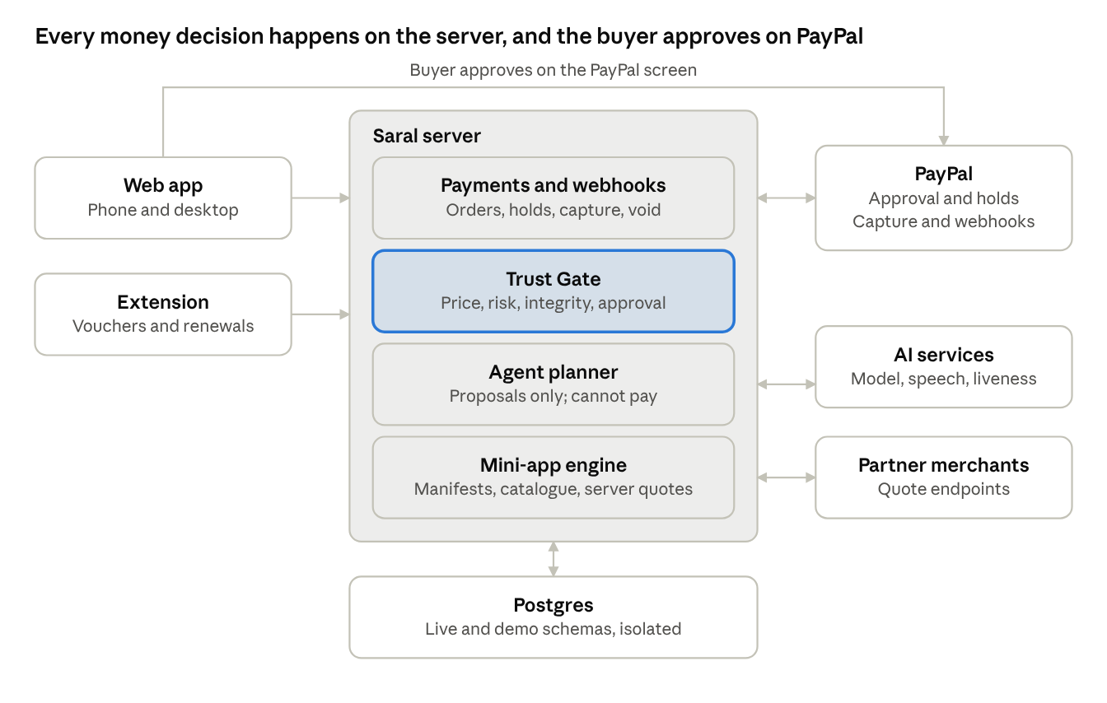
architecture · two clients, one server, three outside services
The web app and extension talk only to Saral's server. The server creates and settles money through PayPal, while the buyer's approval happens on PayPal's own screen.
Stack
Layer | Choice | Why
Web app and site | Next.js (App Router), React, TypeScript, Tailwind, shadcn/ui | One codebase for landing site and app; check PayPal's official boilerplate first
Backend | Next.js server route handlers, plus a worker and cron jobs on Render | Keeps one deployable and one language
Database and auth | Supabase Postgres and Auth, row-level security, schemas live and demo | Strong isolation for the two layers
Payments | PayPal REST API from the server, PayPal JavaScript SDK in the browser | Card data never touches Saral
Agent | LLM with structured output, Zod validation, manifest-derived tools, PayPal Agent Toolkit and sandbox MCP (read tools) | Safe, inspectable tool use
Voice | Browser MediaRecorder, hosted speech-to-text, liveness service | Voice starts, never approves
Ledger | AG Grid | Sponsor tool used for a real job
Extension | Chrome Manifest V3, TypeScript, React popup | Third product surface
Hosting | Render for the app, worker and cron; Supabase for data | Render prize and simple ops
Quality | Vitest, Playwright, gitleaks before every push | Evidence for judges
Data model. Every table below exists in both the live and demo schemas.
Domain | Tables
Identity | users, profiles, consents, limits, extension_devices
Catalogue | merchants, miniapps, catalog_items, quotes, partners
Cinema | cinemas, screens, films, showtimes, seats, seat_holds, bookings
Power bank | stations, devices, rentals, rental_events
Recharge and bills | operators, plans, recharges, billers, bills, settlements
Agent and voice | agent_sessions, agent_messages, tool_calls, voice_requests
Trust and payments | proposals, proposal_items, gate_decisions, approvals, payments, holds, webhook_events
Rewards and subscriptions | vouchers, voucher_events, rewards_ledger, subscriptions, subscription_events
Audit and extension | audit_events (append-only), domain_index (derived per user)

13. PayPal integration map
PayPal is not a checkout button added at the end. It is the part of the system that makes the agent safe: money is held first, released or captured later, and the user approves on PayPal's own screen. Every endpoint and field below must be checked against the current PayPal documentation and the sandbox before we rely on it.
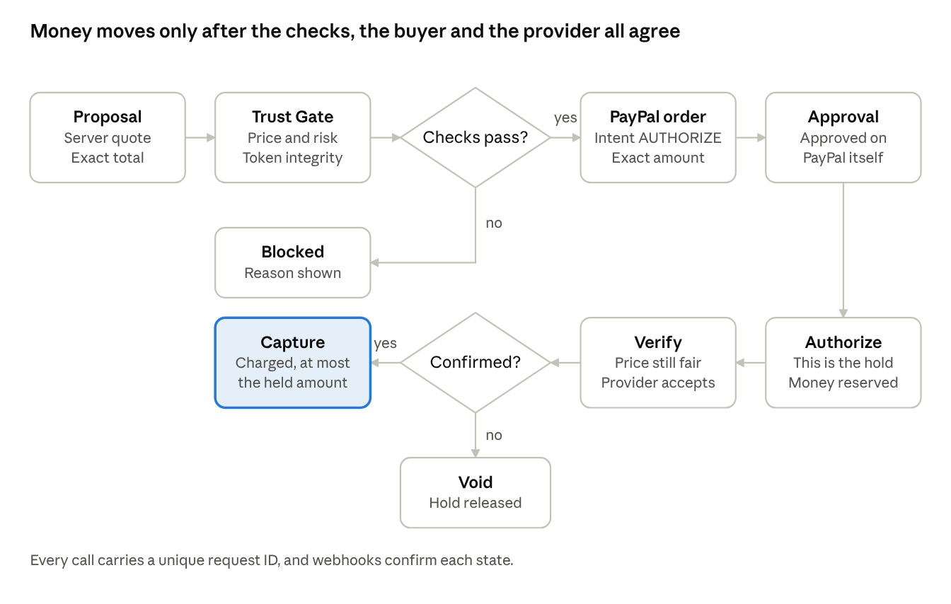
payment lifecycle · hold, verify, then capture or void
A failed check blocks the payment before an order exists. After the hold, a failed confirmation voids it and releases the money. Capture happens only when everything agrees.
Step | PayPal piece | Who calls it | Notes
1. Create order | POST /v2/checkout/orders, intent AUTHORIZE | Server | Amount from the server quote. Reference ID is the proposal hash. A unique PayPal-Request-Id makes it idempotent.
2. Buyer approves | PayPal JavaScript SDK buttons | Browser | The user approves on PayPal. Card data never reaches Saral.
3. Authorize | POST /v2/checkout/orders/{id}/authorize | Server | The authorization is the hold. Store its ID and validity window.
4. Verify | Saral Trust Gate and fulfilment check | Server | Not a PayPal call. Price, risk, integrity and provider acceptance.
5. Capture | POST /v2/payments/authorizations/{id}/capture | Server | Never above the authorized amount. Final capture releases the rest, to be verified for the power-bank deposit.
6. Void | POST /v2/payments/authorizations/{id}/void | Server | When checks fail, the user cancels, or the hold times out.
7. Refund | POST /v2/payments/captures/{id}/refund | Server | When fulfilment fails after capture.
8. Subscriptions | /v1/billing/plans, /v1/billing/subscriptions, suspend and cancel | Server | Only for subscriptions created inside Saral.
9. Webhooks | Order approved, authorization created and voided, capture completed, denied and refunded, subscription events | PayPal to server | Verified with /v1/notifications/verify-webhook-signature, then deduplicated by event ID. Routed by mode (live or demo).
10. Agent tools | PayPal Agent Toolkit and sandbox MCP | Agent | Read tools only. Order creation is never exposed to the model.
11. Payouts (stretch) | /v1/payments/payouts | Server | Only if enabled and verified on the sandbox business account.
12. Reconciliation (stretch) | Transaction Search | Worker | Flags mismatches in the ledger.
PayPal in every feature
Feature | PayPal's role
Cinema | Hold for the ticket total; capture on booking confirmation; void on timeout
Power bank | Hold for the deposit; capture the real fee; release the remainder
Recharge and utilities | Hold until the provider accepts; capture or void; refund if settlement fails
Agent and voice | Read-only status lookups; approval always on PayPal
Rewards | Capture webhook triggers vouchers; discounts reduce the next order amount
Subscriptions | PayPal Subscriptions API for Saral subscriptions
Ledger | Webhooks and IDs drive the timeline
To verify in the sandbox before building around it: partial capture with release of the remainder; INR support (default to USD); card brand and last digits in order responses; Log in with PayPal; Payouts; authorization validity windows; and which Agent Toolkit tools exist today.

14. Security layer and abuse cases
Security is built in from the first commit. The table lists what we defend against, the control, and how we prove it. We do not claim to stop every fraud or deepfake attack; we claim every payment is bounded, explained and approved.
Threat | Control | How we prove it
Amount changed after approval | Signed approval token bound to proposal hash, amount and expiry; server recalculates; capture never above authorization | Attack Lab case and unit tests
Prompt injection in catalogue or merchant text | Catalogue text treated as data; schema-validated output; policy in code; read-only PayPal tools | Attack Lab case
Replayed or synthetic voice | One-time phrase and nonce; liveness check adds friction; approval always separate | Attack Lab case
Duplicate click or duplicate webhook | Idempotency keys and event deduplication | Automated tests
Forged webhook | Signature verification through PayPal before any state change | Automated test
Stolen session | httpOnly, Secure, SameSite cookies; CSRF protection; re-authentication to raise limits | Automated tests
Page script abusing the extension | Closed Shadow DOM, text-only rendering, origin-checked messaging, scoped token | Extension tests
Lookalike domain | Registrable-domain matching with punycode checks | Extension tests
Agent over-reach | Allow-listed tools generated from manifests; no access to keys, vouchers or approval signing | Code review and tests
Leaked secrets in a public repo | Environment variables, .env.example, gitleaks before every push | CI check
Injection, XSS, open redirect | Parameterised queries, input validation, content security policy, validated redirect targets | Scans and tests
Live and demo data mixing | Separate schemas, separate roles, mode-gated modules | CI test: a live account sees zero demo rows
Abuse of the agent or voice endpoints | Rate limits per user and per IP | Load test
Fail safely. If the Trust Gate, the liveness service or a provider is unavailable, voice and high-value payments wait. They are never waved through.
Signals add friction, never remove it. No check can lower the level of verification set by another.
Attack Lab (Demo Mode only). Three one-click attacks, each ending in a plain-language block:
- A film description containing hidden instructions to change the total.
- The amount swapped after the user approved.
- A replayed voice recording.
Honest limits we state: the price check works with partner merchants that publish a quote endpoint; the risk rules are deterministic, not a production fraud model; the extension cannot see cards saved on other websites.

15. Privacy, transparency and legal approach
Saral is built for real users, so privacy is a product feature, not a footer link. This section states our design intent. It is not legal advice, and a qualified lawyer must review the policies and the payments model in each country before any live launch. The hackathon build runs on PayPal Sandbox, and Demo Mode holds no real personal data.
What we hold, why, and for how long
Data | Why | Where | Kept | User control
Name and email | Account and sign-in | Database | Until the account is deleted | Edit, delete
PayPal order, authorization and capture IDs, amounts | Ledger, support, financial records | Database | As the law requires for financial records | Export; deletion keeps only required records
Card numbers and PayPal password | Never collected | PayPal only | Not applicable | Not applicable
Proposals and activity | Ledger and explanations | Database | Until deletion | Export, delete
Voice audio | Transcription only | Not stored | Discarded after transcription | Off by default; revocable
Voice transcript | Editable request and audit | Database | Short fixed period (proposed 30 days) | Delete
Approximate region bucket | Price check | Database | While the permission is on | Off by default; revocable
Phone number for recharge | To complete the recharge | Database, encrypted, masked in screens and logs | Until fulfilment plus a short support window | Delete
Vouchers and saved subscriptions | Rewards and reminders | Database and extension cache | Until expiry or deletion | Edit, delete
Extension device token | Pairing | Database (hash only) | Until revoked | Revoke
Matched-site list | Local matching | On the device | Until unpaired | Clear
Server logs | Security and debugging | Log store, personal data redacted | Short fixed period (proposed 30 days) | Not applicable
Rights we design for. Users may be in India, Europe or the United States, so we build to the shared core of GDPR, India's Digital Personal Data Protection Act and the US state privacy laws: clear notice, consent that is as easy to withdraw as to give, data minimisation, access and export, correction, deletion, and a named contact for complaints. We commit not to sell personal data or use it for advertising.
Documents we publish
- Privacy Policy with a plain-language summary at the top.
- Terms of Service (18 and over).
- In-app Permissions page showing every permission, its purpose and an off switch.
- Sub-processor list: database and hosting, the AI model provider, the speech provider, the liveness provider, and PayPal.
- Data retention schedule and the regions where data is stored, including cross-border transfers.
- Security overview and incident response process, including how and when users are told about a breach.
- Extension privacy disclosure listing each permission in plain words.
- Open-source licence and third-party notices.
How transparency appears in the interface
- Each permission is asked at the moment it matters, with one sentence of purpose, and starts off.
- An AI notice on the agent screen says the model sees the request and the options it is comparing, not payment details.
- A payment notice says payments are made through PayPal and Saral never sees card details.
- Holds are explained where they appear: Held means PayPal has reserved the amount and you are not charged yet.
- No dark patterns: declining is as visible as accepting, and nothing is pre-ticked.
- Cookies are strictly necessary only (session and CSRF). There are no advertising or analytics trackers.
Payments and regulation. Saral never holds customer money. PayPal processes payments under its own user agreement and is the regulated provider. Whether Saral's role as a marketplace for partner services triggers licensing or registration in a given country is a question for counsel before live launch.
Honest status. Everything above is a design target and a draft. Until a lawyer signs off, the product is presented as a sandbox prototype.

16. Winning strategy
We read PayPal's hackathon page, its agentic-commerce announcements and the previous Dev Days winners. The consistent message: PayPal wants AI agents to shop and pay, while the buyer stays in charge and PayPal keeps approval and authentication inside its own checkout. Saral is built on exactly that line.
What PayPal says it wants, and how Saral answers
PayPal's stated direction | Saral's answer
Agents can discover products, build carts and start checkout, but the buyer approves on PayPal (Agent Ready) | The agent proposes; money moves only after approval on PayPal's screen. The Attack Lab proves the agent cannot go around it.
Trust is central: PayPal keeps payment approval, authentication and buyer protection | Authorize first, verify, then capture or void. Saral never touches card data.
An open platform so partners can enable agentic commerce (Dev Days announcement) | Public mini-app manifest and quote contract; a Developers page; a Saral MCP server (below).
Build with the Agent Toolkit and MCP servers | Used inside the agent with read tools, documented in the README.
What the previous winners teach us. The Dev Days winners were an AI agent that gets past paywalls using PayPal, an upgrade of a real e-commerce platform to PayPal's newer JavaScript SDK, and a PayPal-powered trading app. All were concrete, working and deeply tied to PayPal. That was a different event with a different panel, so treat it as a hint, not a rule. For this hackathon the judges are mostly PayPal developer advocates and engineers, so real depth in PayPal usage matters more than breadth.
The five judging criteria
Criterion | Our answer | What to make visible
Technological implementation | Authorize, capture, void, refund, webhooks, idempotency, subscriptions, Agent Toolkit and MCP, AG Grid ledger, signed approvals | An architecture diagram and tests in the README
Design | One coherent product across web app and extension, a strict monochrome system, designed empty and error states | Polished flows in the video
Potential impact | Agents will soon handle money; people need to see and approve it. Everyday users with scattered services and missed rewards | A one-line audience and honest limits
Innovation | A PayPal hold as the agent's allowance; rewards that follow you to the right website; services as manifests | Three clear moments in the demo
Presentation | A tight story under three minutes, end to end | Section 17 script
Prizes we target
Prize | Why we fit | What must be true
1st to 3rd place | A complete, safe, working flow | The full journey runs without a failure
Best Use of Agentic Commerce | Agent plans across mini-apps; cannot pay; external agents can use the Saral MCP server | Agent Toolkit or MCP used in earnest
Best Use of PayPal + AI | Hold, verify, capture, void, subscriptions | Partial capture verified or honestly replaced
Most Impactful | Trust for AI-handled money | The audience and the problem are stated clearly
Best Demo Delivery | One story, under three minutes | Rehearsed and cut
Most Creative | Hold as allowance; rewards that follow you | Shown, not described
AG Grid | The ledger is the product's source of truth | Real grid features in use
Render | Deployed on Render | A render.yaml blueprint
APIMatic | PayPal context plugin used while coding | Use documented in the README
Whether one project can win more than one prize is not stated on the pages we read. Check the Official Rules.
New features added to raise our odds
Feature | Why it helps | Priority
Saral MCP server exposing search, quote and propose tools (no pay tool) so any external agent can plan with Saral and still needs the user's approval | Matches PayPal's open agentic platform direction; strong for Agentic Commerce | Strong
Spending mandate: the user sets budget and merchant rules the agent must stay within, shown on every proposal | Makes the trust story visible | Must
"Why was this held?" explanation on every gate decision | Explainability and design score | Must
Hold ring on Home showing time left on any hold | Clear, memorable visual | Strong
OpenAPI description of the manifest and quote contract, with docs or SDK generated through APIMatic | Developers page and sponsor prize | Strong
One-click deploy blueprint for Render | Judge convenience and Render prize | Strong
Report a problem: a prefilled summary that hands off to PayPal's dispute process (needs verification) | Impact and trust | Stretch
Ledger export to CSV | Everyday utility | Stretch

17. Demo video script and submission checklist
The video runs about 2 minutes 45 seconds, under the three-minute limit. It opens on the separate Demo page so the demo credentials are shown before the product, which keeps the working product free of demo wording.
Time | Scene | What the viewer sees | What it proves
0:00 to 0:10 | The Friday evening problem | Scattered apps, an expired voucher, a surprise renewal | The pain is real and familiar
0:10 to 0:20 | Demo page | Demo credentials entered, workspace opens with the slim demo bar | A separate, honest demo layer
0:20 to 0:45 | Ask by voice | Spoken request, editable transcript, three proposals with totals | Voice starts, the agent plans from real catalogue data
0:45 to 1:05 | Trust Gate | Checks run, the price check flags one option, the AI explains, the user switches | Checks add friction and explain themselves
1:05 to 1:20 | Approve with PayPal | PayPal sandbox approval, hold appears, then Charged | Hold, verify, pay with the exact approved amount
1:20 to 1:35 | Power-bank rental | Deposit held, device returned, fee captured, remainder released | Partial capture and release (or the labelled fallback)
1:35 to 1:50 | Activity ledger | AG Grid row opens a timeline from proposal to capture | An auditable record
1:50 to 2:15 | Extension | Voucher card on the partner cafe site; subscription card on the service site | Rewards and subscriptions that follow the user
2:15 to 2:35 | Attack Lab | Three attacks, three plain-language blocks | The agent cannot spend on its own
2:35 to 2:45 | Close | Hold. Verify. Pay. Digital life, made simpler. | A line people remember
Rules for the video. It must show the project working on the device it was built for, be uploaded to YouTube as public, and use no third-party trademarks or copyrighted music. All merchants and partner sites are fictional.
Submission checklist
- ☐ Public GitHub repository with the licence file visible in the About section
- ☐ README with clear setup and run steps, the architecture diagram and the demo credentials
- ☐ Hosted demo URL on Render, plus run-it-yourself instructions as a backup
- ☐ Extension build and load-unpacked instructions, and a zipped build
- ☐ Devpost text description of features and functionality
- ☐ Tools list: which AI models and services were used and how, including Agent Toolkit, MCP, AG Grid and Render
- ☐ Devpost testing notes with the demo account and the sandbox buyer (never in the public repo)
- ☐ YouTube video under 3 minutes, public, link on the form
- ☐ gitleaks run clean and .env.example present
- ☐ Official Rules read again, including prize stacking and the exact deadline
- ☐ Submitted at least one day before the deadline

18. Build roadmap, cut order and open checks
Submissions close on 12 November 2026 at 12:00 PM Pacific, which is 13 November, 12:30 AM IST. We aim to submit on 11 November. The plan below has no slack, so the cut order is decided now, not on the last night.
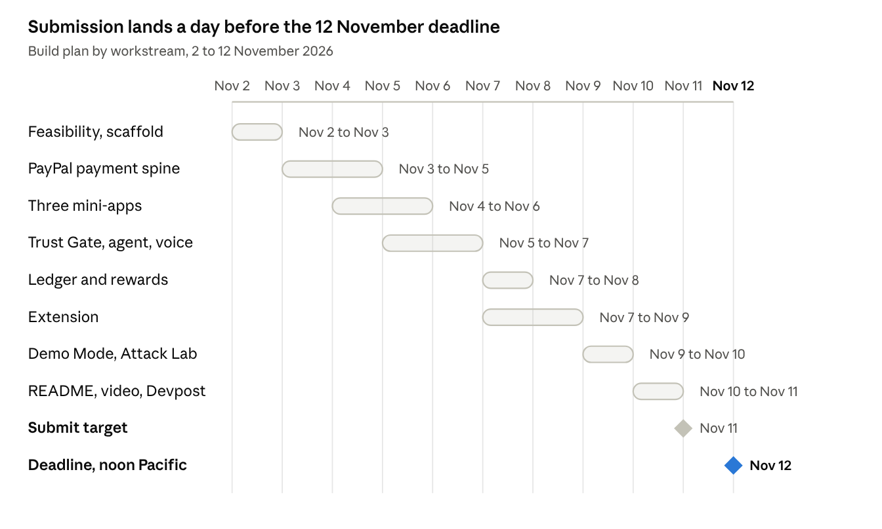
roadmap · 8 workstreams and 2 milestones, 2 to 12 November
Workstreams overlap on purpose. The payment spine and the three mini-apps start before the Trust Gate is finished, and the extension runs beside the ledger.
Cut order
Priority | Feature | Decision
Must ship | PayPal payment spine, Trust Gate, signed approval | Never cut
Must ship | Cinema, power-bank and recharge on the shared engine | Never cut
Must ship | AI agent with proposal and approval flow, text input | Never cut
Must ship | Activity ledger in AG Grid | Never cut
Must ship | Demo Mode with seed data, README, licence, video | Never cut
Must ship | Extension: voucher card and subscription card | Core companion
Strong | Voice start with editable transcript | After the text flow works
Strong | Utility payments, spending mandate, Saral MCP server | Build if the core is stable
Stretch | Liveness check on voice | After voice works
Stretch | Cashback payout, report a problem, CSV export | Cut first
Verify first (Set 0)
- ☐ Partial capture and release of the remainder on an authorization
- ☐ Sandbox currency: confirm USD works, test INR
- ☐ Card brand and last digits in order responses
- ☐ Log in with PayPal availability on the sandbox app
- ☐ Payouts enabled on the sandbox business account
- ☐ Agent Toolkit and sandbox MCP: which tools exist, and a read-only connection
- ☐ Speech-to-text quality for mixed-language speech
- ☐ Liveness service latency and response format
- ☐ AG Grid features available with the hackathon access
- ☐ Prize stacking in the Official Rules
- ☐ Whether PayPal supports the markets we describe for domestic payments
- ☐ Name clearance for Saral: trademark, domain, GitHub, Devpost and social handles
- ☐ Confirm "Love Over Coffee" is not an existing business before using it in the demo
Sources. Opened for this document, as of 2 November 2026:
- Build What's Next with PayPal and AI (hackathon post)
- Dev Days hackathon winners
- PayPal Agent Ready and WebMCP
- PayPal Dev Days announcement on agentic commerce
- The hackathon rules, prize list, judges and criteria were taken from the hackathon page you attached.

